

COMPUTER NETWORKS
ASSIGNMENT 01
Group Members:

i) Bilal Ahmed Khan (20k0183)
ii) Muaaz Alam (20k0212)

Task:

Develop a simple “Chat Messenger” that is connection oriented (i.e. it uses TCP) and that
consists of a Client and a Server Program.
1) The Server runs first and waits for some client to contact it.
2) Client Program starts and connects to the server.
3) Client-Server sends and receives messages.

Libraries Used:

i) Tkinter:

Python library for creating Graphical User interface.

ii) Threading:
Used to created threads for sending and receiving messages.

iii) Socket:
For creating sockets for communication between server and clients.

Working of Program:

i) Server Side:
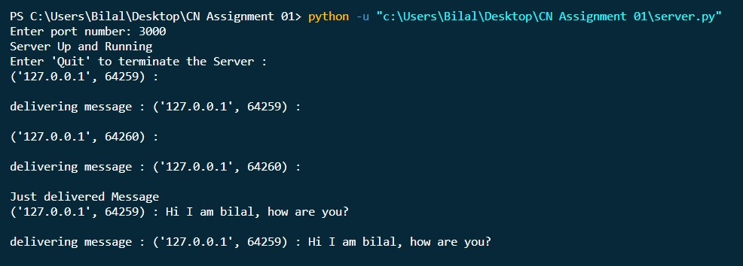
ii) Client Side

Client 01:

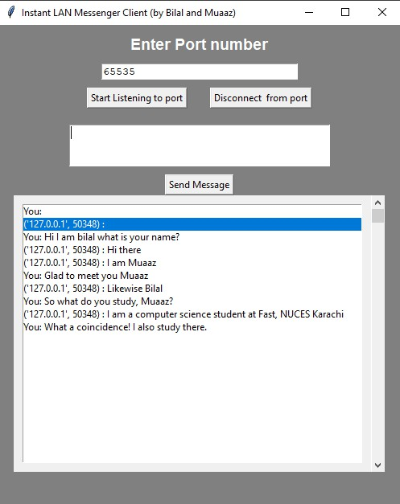
Client 02)

